Name: ____________________________________________________________ Date: ________________________

**Unit 2 Test Review**

**Study your properties! Give an example of each of the following:**

Commutative: x + y = y + x Associative: (2+4)+6 = 2+(4+6) Distributive: 2(x+4)=2x+8

Additive or Multiplicative Inverse: a + -a = 0 Additive or Multiplicative Identity: 22b x 1 = 22b

**Find the solution of the linear system graphically. Write your solution in the blank provided.**

**_(1, 2)___**1. _(2,3)___2.



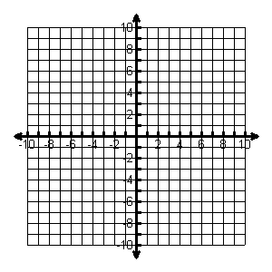 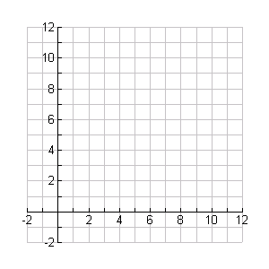

**Use substitution to solve the linear system. SHOW ALL WORK and write your solution in the space provided.**

_(2,2)___3.  _(-2,-2)__4.

**Use elimination to solve the linear system. SHOW ALL WORK and write your solution in the space provided.**

_(2,1)__5.  _(1, -2)_6.

**Use any method to solve the linear system. SHOW ALL WORK and write your solution in the space provided.**



__No Solution__7. 

**Systems of Linear Equations Word Problems:**

8. Bill wants to buy some CDs at the music store. Used ones sell for $4.99, and new ones sell for $13.99. He has $75 to spend that he got for his birthday.

a) Write a linear inequality to represent the situation. Can Bill by 4 used and 4 new CDs?

4.99u + 13.99n ≤ 75; No, not enough money by $0.92

9. A store sold 32 pairs of jeans for a total of $1050. Brand A sold for $30 per pair and Brand B sold for $35 per pair. How many of Brand A were sold?

A + B = 32 Answer: 14 of Brand A and 18 of Brand B

30A + 35B = 1050

10. You are selling tickets for a basketball game. Student tickets cost $3 and general admission tickets cost $5. You sell 350 tickets and collect $1450. How many of each type of ticket did you sell?

S + G = 350 Answer: 150 Student Tickets and 200 General Admission Tickets

3S + 5G = 1450

**Graph the systems of inequalities, and name a solution.**

________11.  _______12.



**Systems of Linear Inequalities Word Problems:**

13. Julia and Jackson are raising money for a Mother’s Day gift. They have a lemonade stand and are selling cups of lemonade for $2 each and cookies for $1.50 each. They must raise at least $150.

* 1. Write an inequality to express the income from the lemonade stand.

2x + 1.5y ≥ 150

* 1. They expect to sell at least 3 dozen cookies. Write an inequality to represent this situation.

y ≥ 30

14. You are looking to buy a bouquet of flowers for your favorite math teacher. Lilies cost $3.00 each and roses cost $4.00 each. You have budgeted no more than $28 to spend on flowers. Graph a system of inequalities to illustrate how many of each type of flower you can purchase if you want to buy at least half a dozen flowers. Explain how to use the graph to determine possible solutions.



3x+4y ≤ 28

X + y ≥ 6